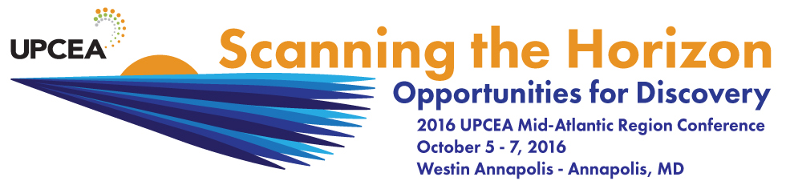

Get Involved in the UPCEA Mid-Atlantic Region!

Regional engagement allows you to meet members from other institutions, build a network of collaborative colleagues, learn new strategies from others, share the great work your institution is doing, and hone your own skills. Take a moment to review the opportunities for engagement listed below, and then select the one(s) that align best with your availability and interests. Thanks in advance for your interest, and we look forward to working with you! - The Mid-Atlantic Regional Council

Awards Committee (Chair: KayMarie Platt, kplatt@widener.edu)
What: This committee seeks and reviews nominations from the regional membership for awards to be presented at the annual regional conference. You would be a good fit for this committee if: You enjoy reviewing and learning about your colleagues’ work, and playing a role in the public presentation of the awards to recipients at the regional conference. Members of this team are organized and deadline driven.

Conference Planning Committee (2017 Conference Chair: Lorelee Islbell, lisbell@passhe.edu)
What: This committee works virtually starting in Nov-Dec, 2016 and meets face-to-face at the conference venue in spring 2017. The committee sets the theme of the regional conference, recruits and selects keynote, concurrent session, and pre-conference workshop speakers, and coordinates and executes a wide range of conference logistics. You would be a good fit for this committee if: You enjoy planning, coordinating, and details, have an interest in providing professional development opportunities for members of the profession, and working as part of a large collaborative team. Members of this team are organized, detail oriented, creative, and deadline driven. The conference planning committee is composed of the following subcommittees: Exhibitors/Sponsors, Host Institution, Marketing and Communications, Meals and Entertainment, Program Content, Welcome and Newcomers.

Emerging Leaders Program (Chair: Dawn Coder, dmh170@psu.edu)
What: This year-long program begins with the pre-conference workshop at the 2016 conference, continues with a year-long collaborative cohort project, and culminates with a presentation at the 2017 Mid-Atlantic conference. The Emerging Leaders Program provides participants with the opportunity to collaboratively explore the theory and practice of continuing education leadership with peers from across the Mid-Atlantic region. The program is designed to prepare the next generation of the region’s leaders. You would be a good fit for this group if: You’re interested in developing and sharpening your leadership skills, engaging in collaborative research and leadership project with colleagues at other institutions, developing your professional network within the region.

Membership Committee (Chair: Rosemary Kelly, rbkelly@uc.syr.edu)
What: This committee works with the regional Membership Coordinator, UPCEA’s national office, and the regional conference planning committee on matters related to membership recruitment, engagement, and retention. You would be a good fit for this group if: This position is well suited for individuals with strengths in building and sustaining connections and networks.

Site Selection Committee (Chair: Carolyn Callaghan, cmcallaghan@ship.edu)
What: This committee works in collaboration with the regional council and UPCEA’s national office to identify future conference locations and venues, and to recruit conference host institutions. You would be a good fit for this group if: You have expertise in conference planning, have an interest in learning about the characteristics of regional members and venues, and meeting members throughout the region.

To get engaged, complete and return the following to the conference welcome table:

Name ________________________________________________________________
Institution ________________________________________________________________
Email ________________________________________________________________
Phone ________________________________________________________________

I’d like to become involved in …

____ Awards Committee ____ Membership Committee
____ Conference Planning Committee ____ Peer Learning Circle Committee
____ Emerging Leaders Program ____ Site Selection Committee
____ Got an idea for a new activity? Is there another way in which you’d like to get involved? Tell us
about it here!

